**EXPERIMENT 6 OUTPUT**

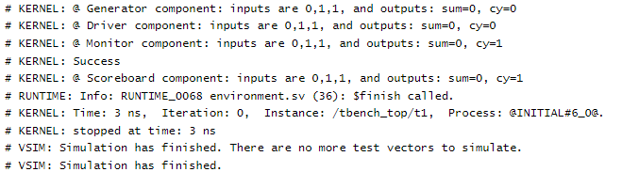

**EXPERIMENT 7 OUTPUT**

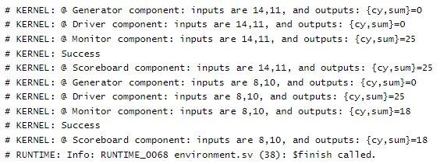

**EXPERIMENT 8 OUTPUT**

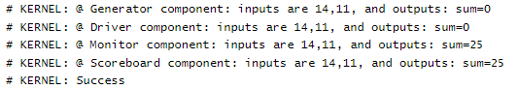

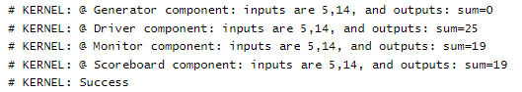

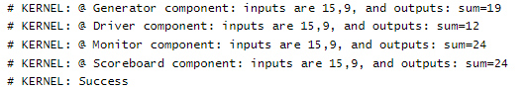 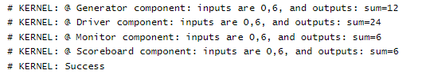 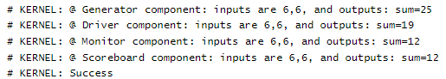

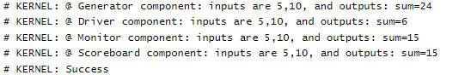



**EXPERIMENT 9 OUTPUT**

**Constraint 1**

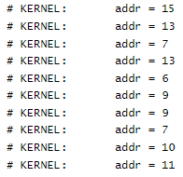

**Constraint 3**

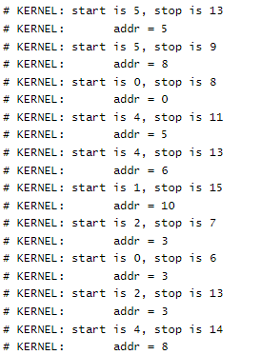

**Constraint 2**

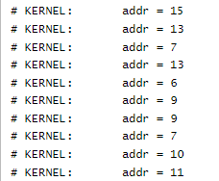

**Constraint 4**

